Trauma & Resistance
Innovative Responses to Oppression, Violence and Suffering
Tuesday Jul 28 & Thursday Jul 30: 9am-12pm
VIRTUAL SESSION
In this workshop, Vikki offers an alternative approach to work with ‘trauma’ from a decolonising, anti-oppression stance which focuses on the resistance of victims of violence and oppression. Honouring the wisdom of the people we work alongside with in their responses to trauma brings forward their agency and wisdom. Vikki will illustrate a witnessing approach to therapy using practice examples and struc-turing safety as the foundation of the work. She will share alternative understandings of ‘trauma’ that resist psychology and the helping professions’ normalizing practice of re-framing oppression, harm and suffering as personal deficit and disguising acts of resistance as trauma and pathology symptoms
Vikki Reynolds PhD RCC is an activist/therapist from Vancouver, Canada, who works to bridge the worlds of social justice activism and therapy. Vikki is a white settler of Irish, Newfoundland and English folks, and a heterosexual woman with cisgender privilege. Her experience includes supervision and therapy with peers, activists, and other workers responding to the opioid epidemic/poisonings, torture and political violence, sexualized violence, mental health and substance misuse, homelessness and legislated poverty and working alongside gender and sexually diverse communities. Vikki is an Adjunct Professor and has written, keynoted and presented internationally on the subjects of ‘Witnessing Resistance’ to oppression/trauma, ally work, resisting ‘burnout’ with justice-doing, a supervision of solidarity, ethics, and innovative group work.
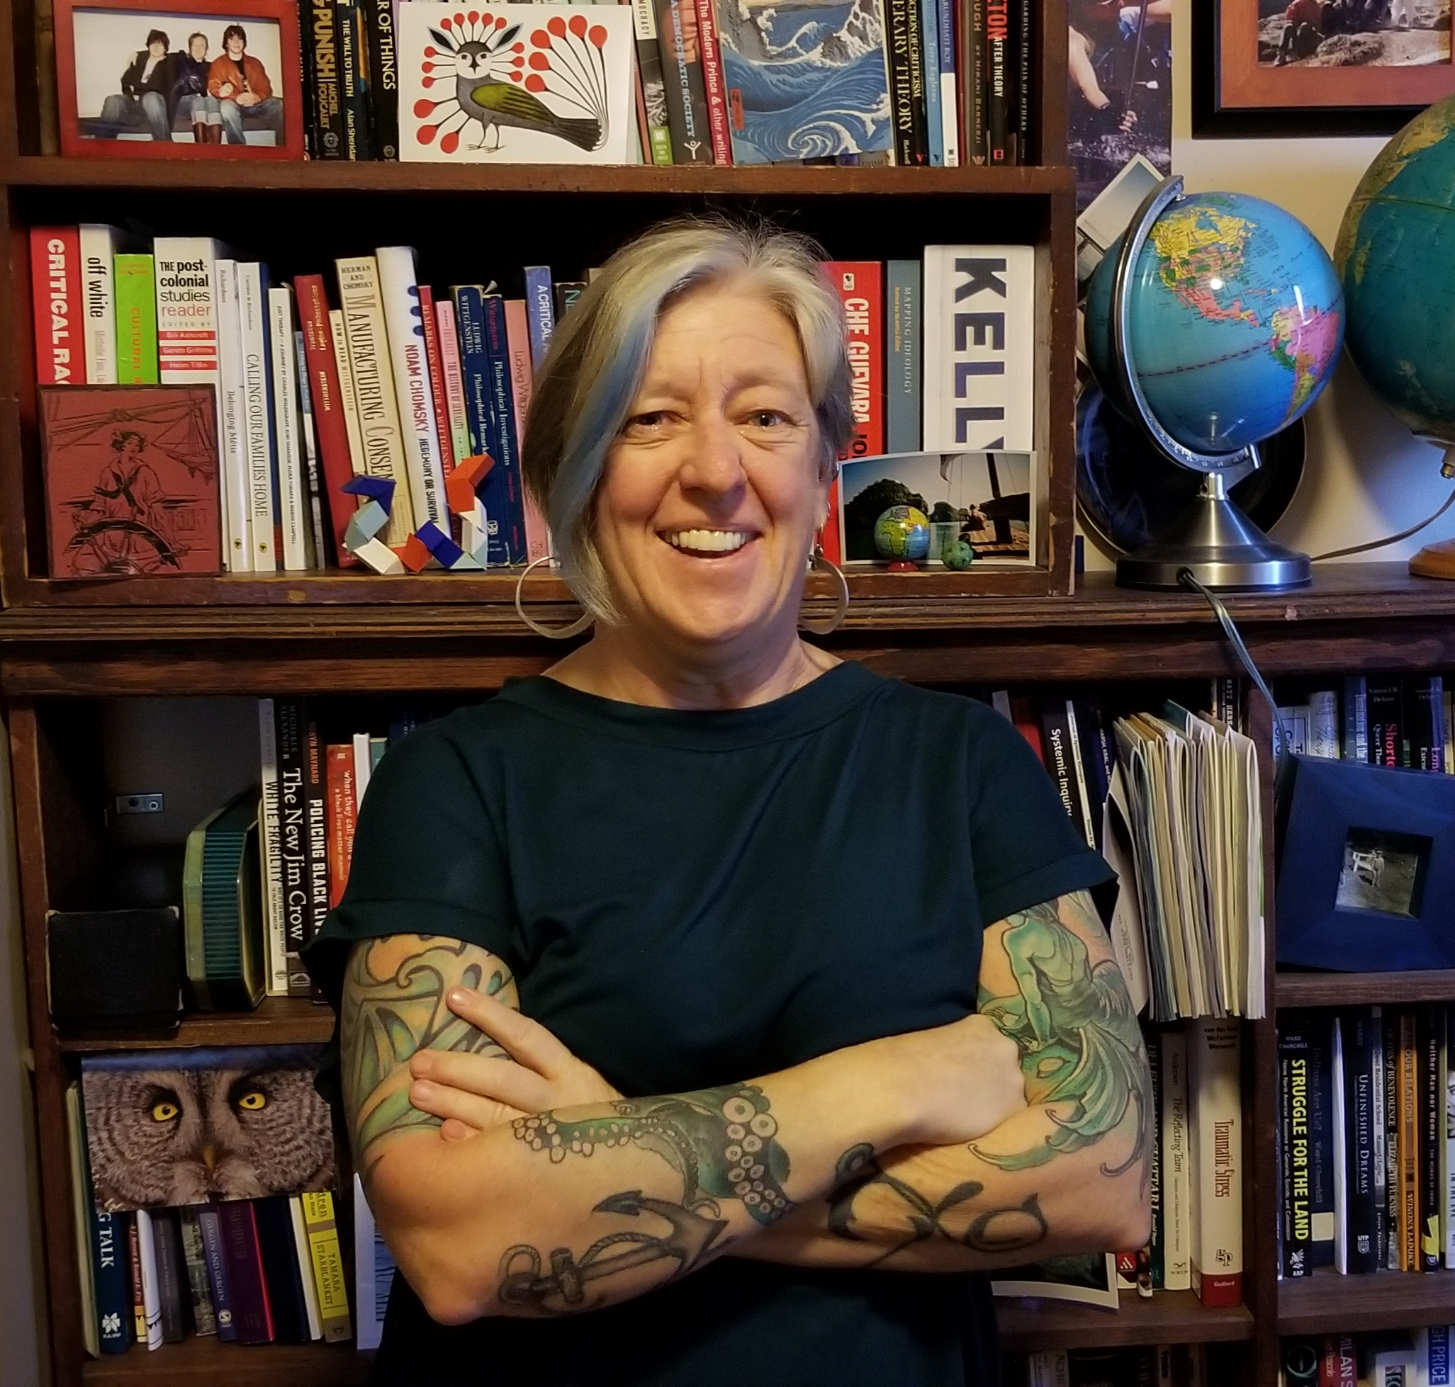
Vikki’s articles and keynotes are available free on her website: www.vikkireynolds.ca

